Loans Management

One significant module to manage all your employees loans

Key Features

Employees Loans Management.
Salary Advances Management
Loans Management & Salary Advances Through The Portal.
Automatic Deductions On Payslips.
Non-payslip Loan Payments.
Fully Integrated With accounting & Finance In Two Ways.*
Compatible with payslip batches.
Unlimited Free Bug Fixes.
Compatible With Odoo Enterprise & Community Editions.

User Guide

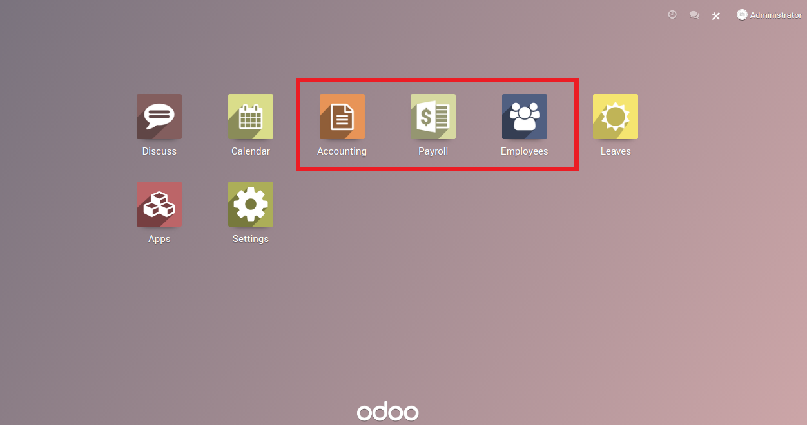
Once you install the Module “SW – Loans Management” the previously highlighted Odoo standard modules will be installed.

Main Configurations

1-Setting the accounting policy.

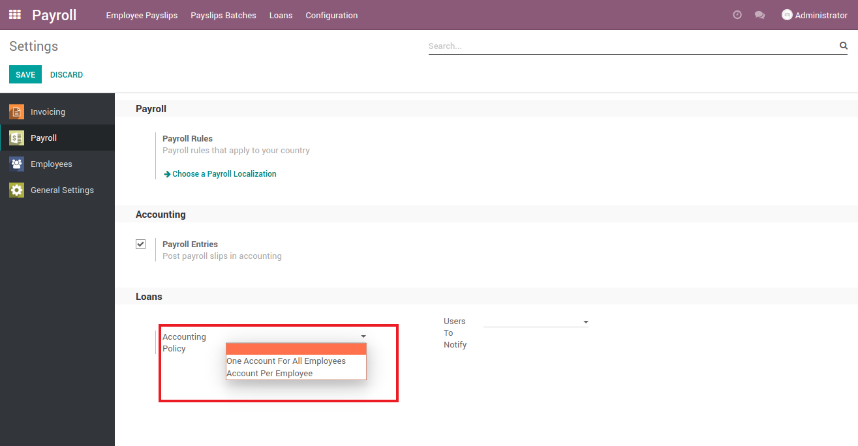
*Set the accounting policy using two ways as seen above :
A-One Account For All Employees
B-Account Per Employee

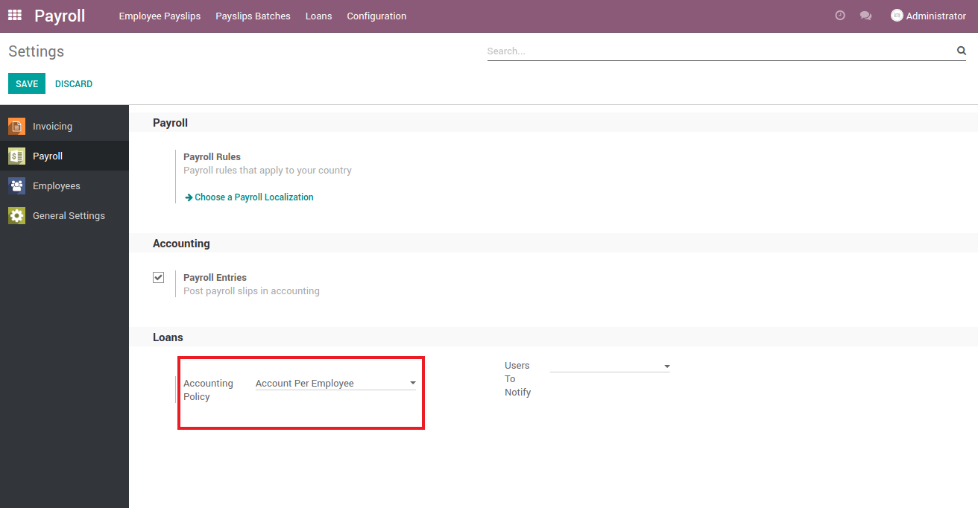
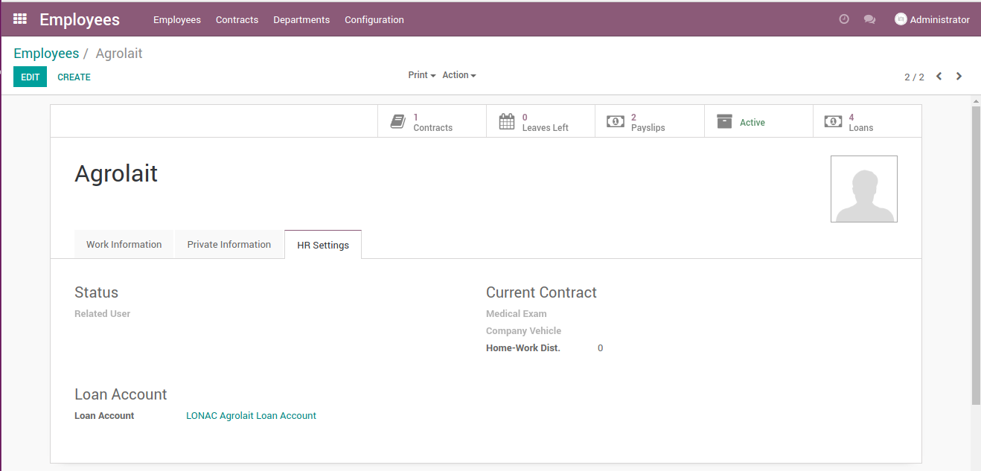
A-Account per employee
A new Field “Loan Account” will be added to the employee profile under “HR Settings” tab.
Using this method helps printing a General ledger for each employee Account.

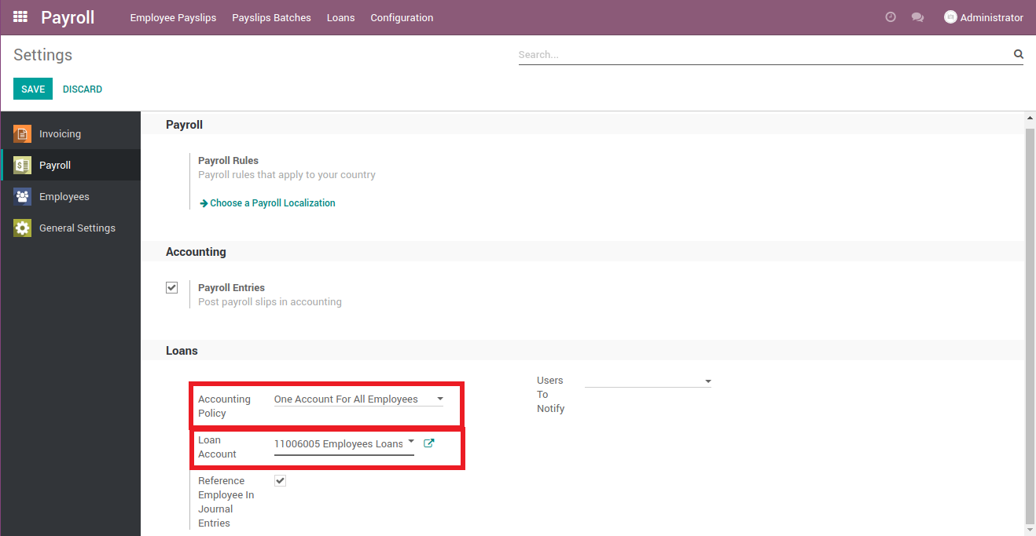
B- Set one account for all employees.

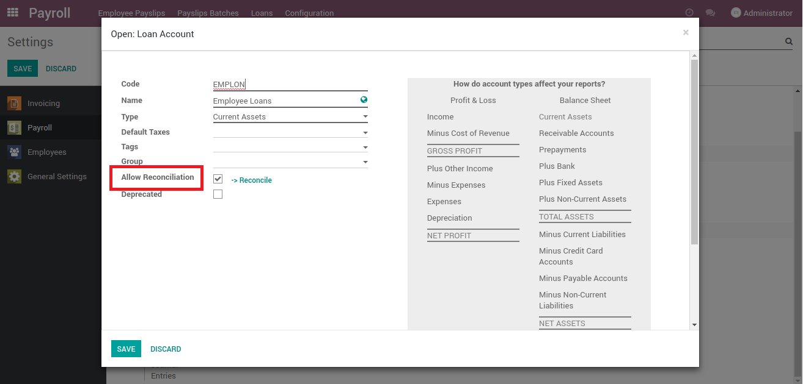
Note: the accounts in the previous two points have to be reconcilable accounts.
Note:each employee will have a related user to avoid extra charges for users we recommend to deactivate the employees related users.
Note:”User to notify” indicates the employees who will be notified if a loan is created.

WARNING:
Changing between the two policies (while loan records in place) may cause unwanted results, so be advised to study and choose the most suitable policy from day one.

This method sets one loan account for all employees ,while the partner name will appear on the payment & journal Items of the loan.

2-Add the loan salary rule to the salary structure(s) of your company where applicable.

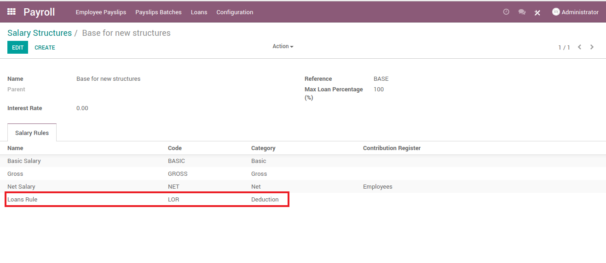
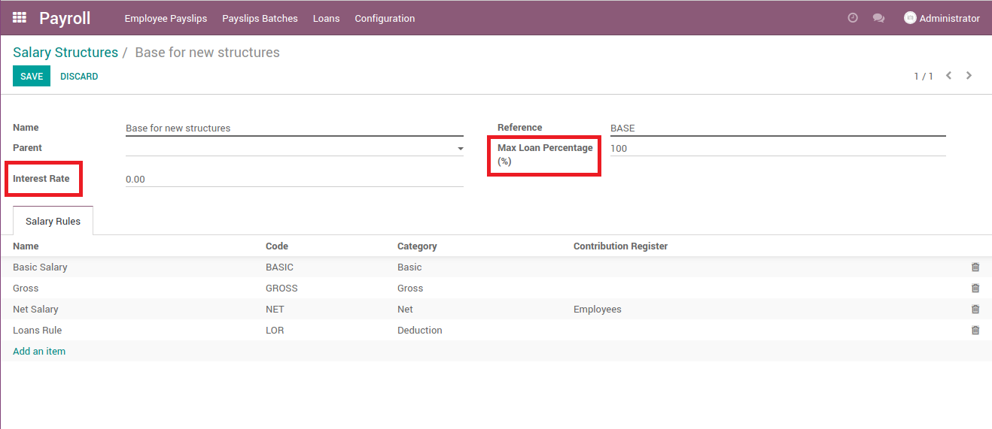
Max Loan Percentage (%): indicates the allowed percentage of the employee wage to be requested as a loan (take in consideration the previous loans balance for the same employee).
Interest Rate: Indicates the interest rate to be added to the loan amount.
3-Define the loan types.

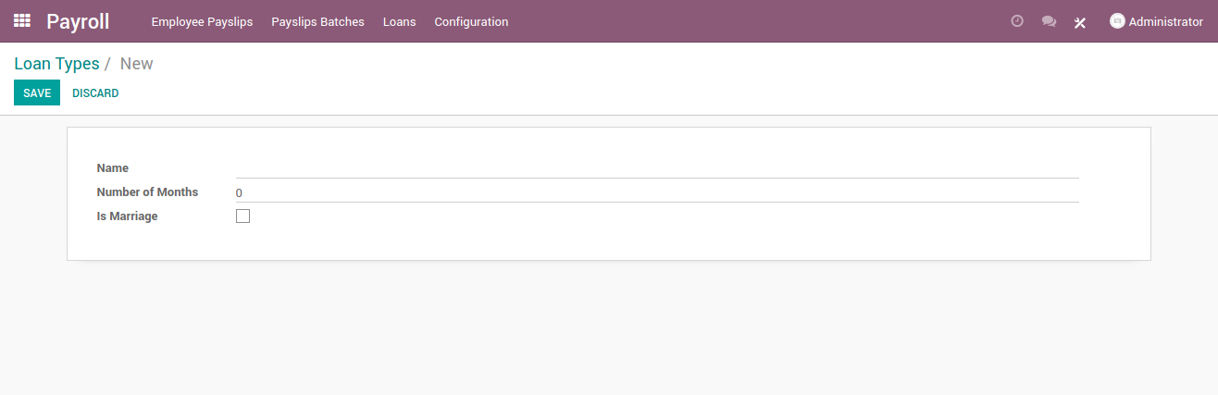
Name: name of the loan type.
Number of Months: the default number of months this loan amount will be settled by.
Is Marriage: Is it a Marriage loan? If it is, this indicates that this loan can be used only once in the service period.

Loan Creation

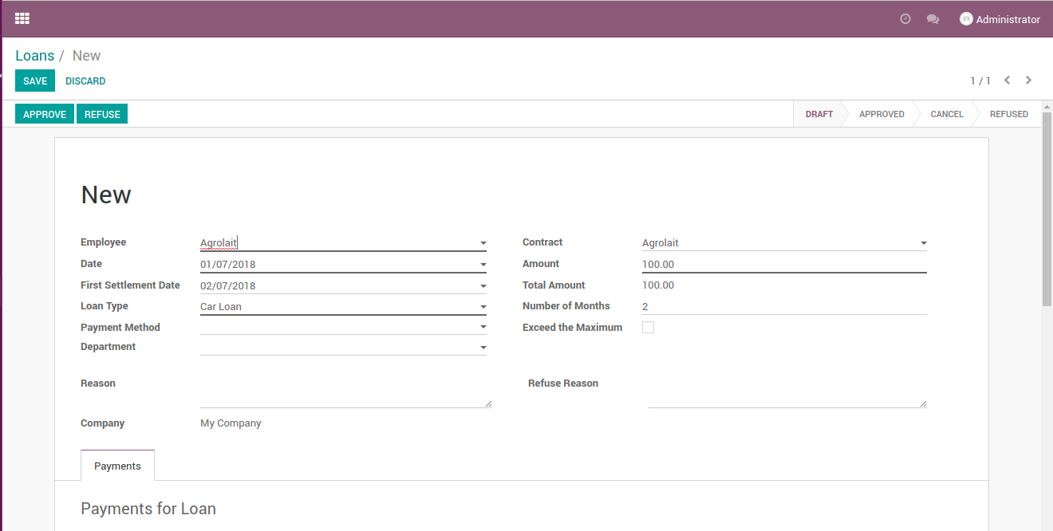

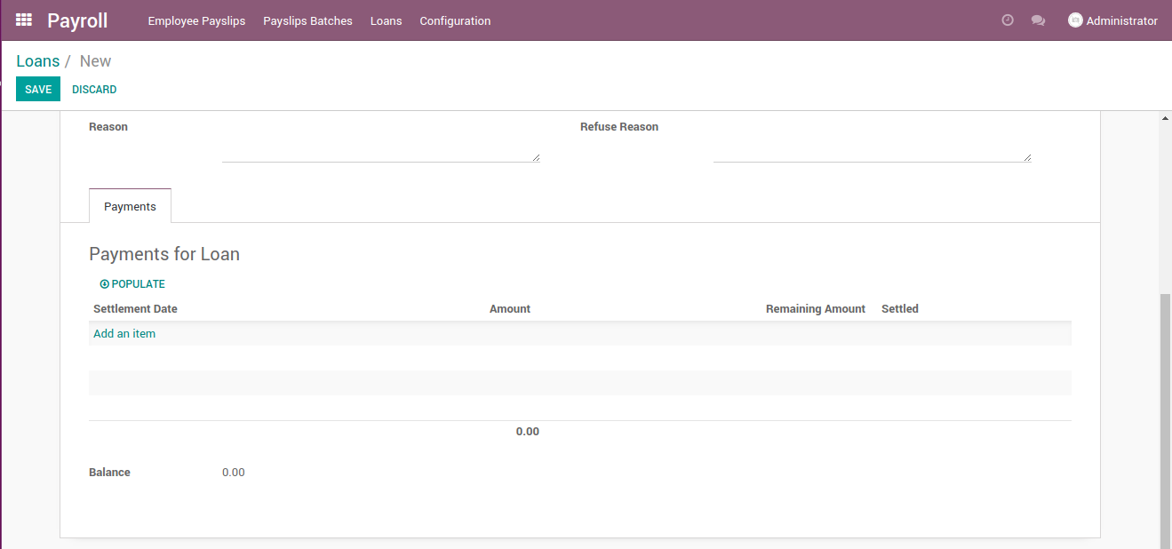
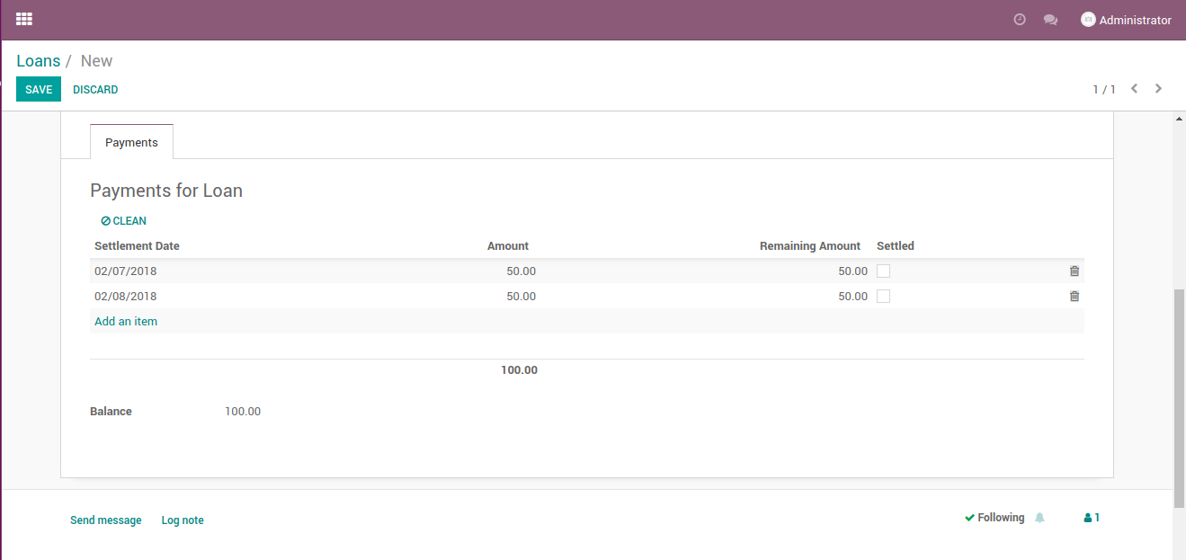
To create a new loan go to Payroll→ loans → create

Date: loan request date.
First Settlement Date: the due date of the first installment.
Amount: loan amount.
Number Of Months: the number of months the loan amount will be divided by (will be set automatically based on the loan type) but can be changed manually in this page.
Exceed the maximum: will be checked automatically if the amount of the loan exceeded the “Max Loan Percentage (%)” defined in the salary structure taking in consideration the previous loans’ balances.
Populate: auto-fill settlement dates (usually on monthly bases).

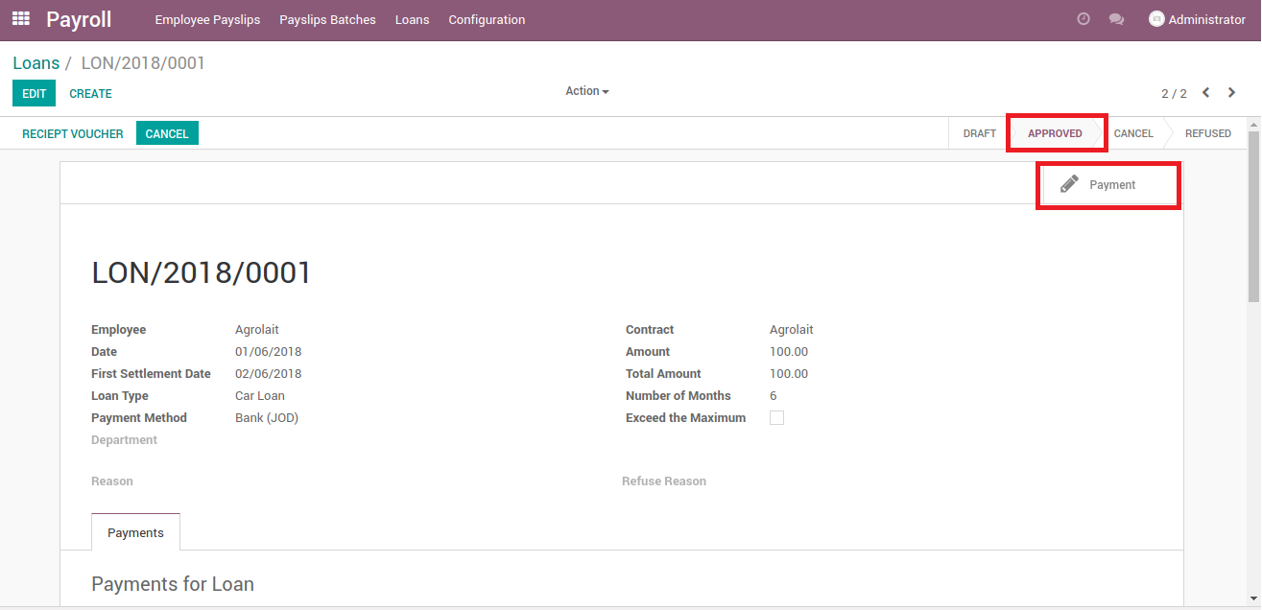
At “Approved” stage “payment” smart button will appear.

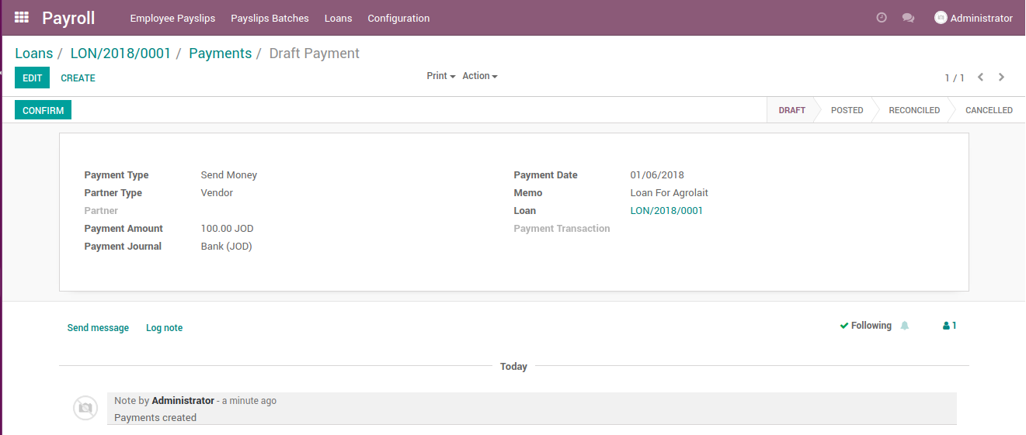
“Payment” is the payment of loan, it will appear in the “Accounting” Module as a vendor payment.
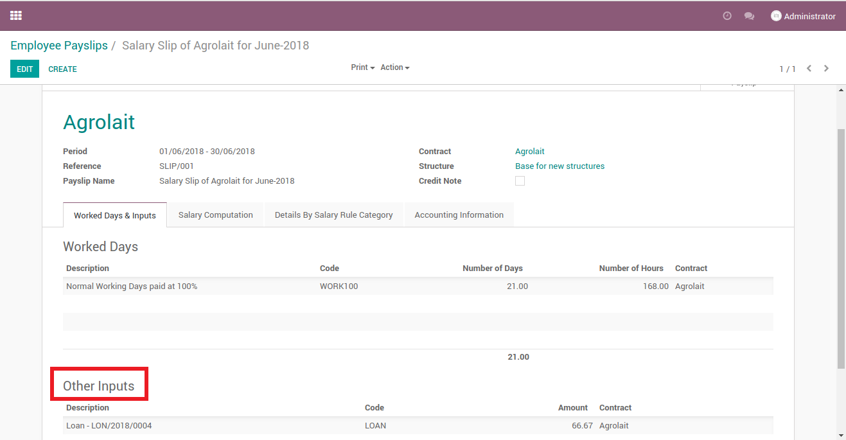
At the creation of the employee payslip the loan will appear under “Other Input” section.

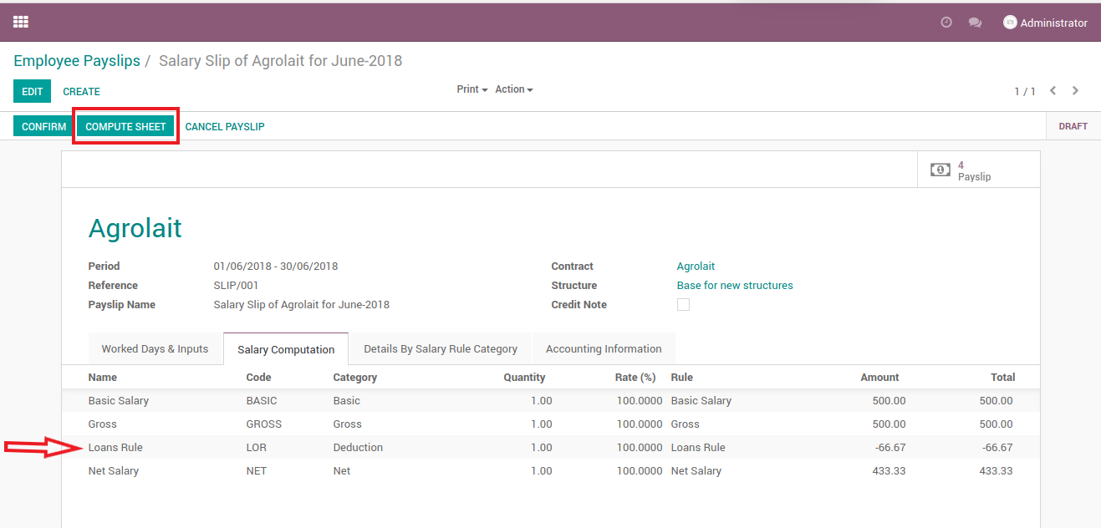
After sheet computation “Loans Rule” will appear under the “Salary Computation” tab.
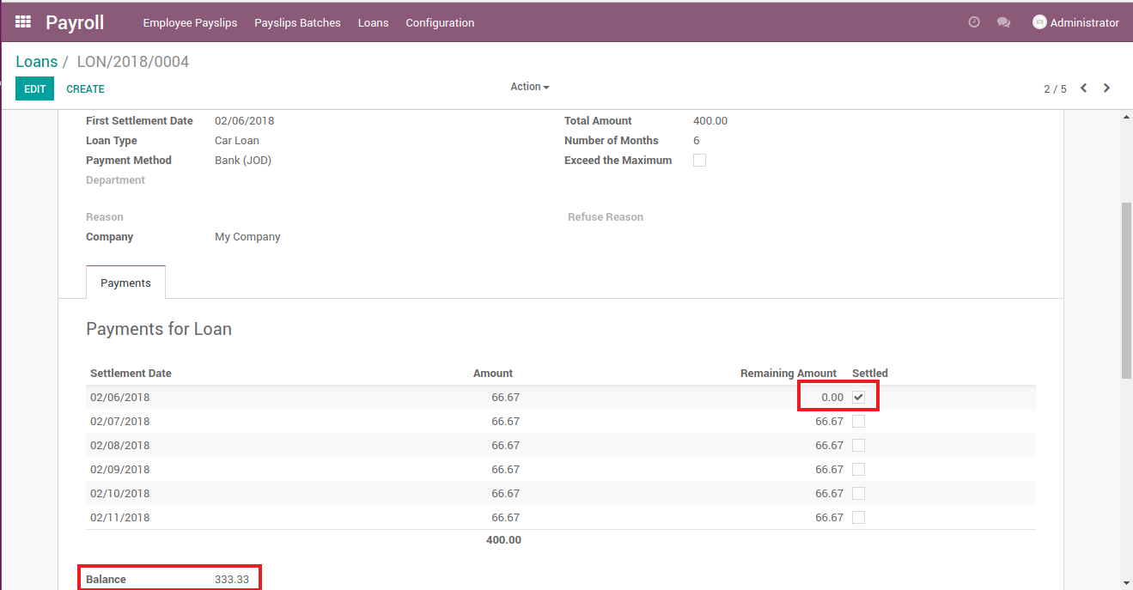
After the confirmation of the payslip the loan amount allocated to the payslip month will be deducted from the loan balance.

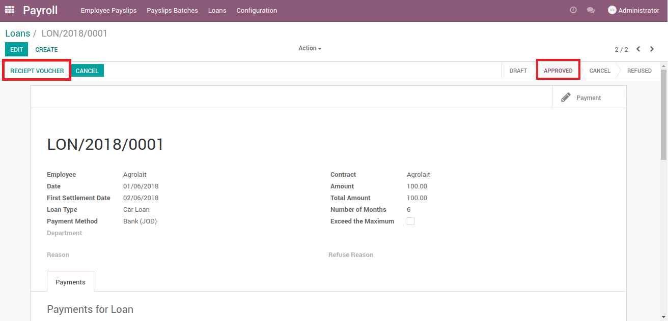
At “Approved” stage “Receipt Voucher” button will appear.

“Receipt Voucher” is responsible for the payments the employee pays in advance (non-payslip payments).

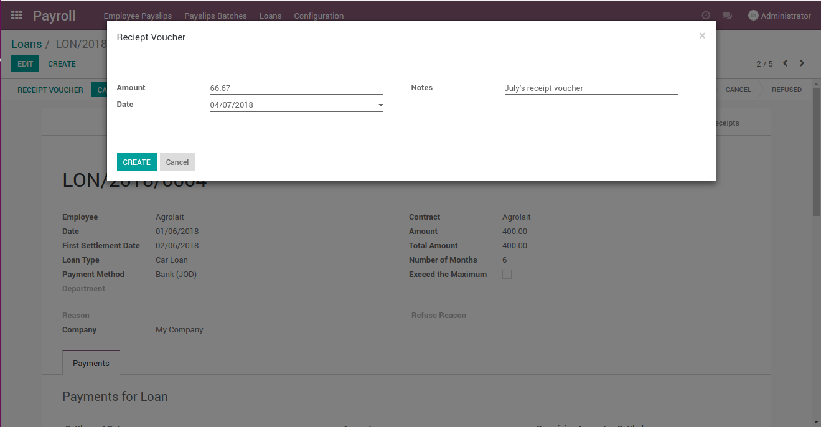

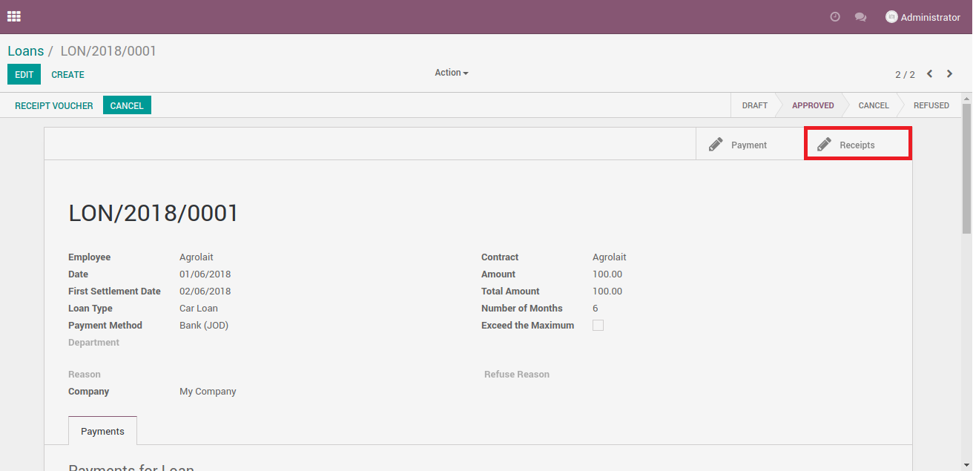

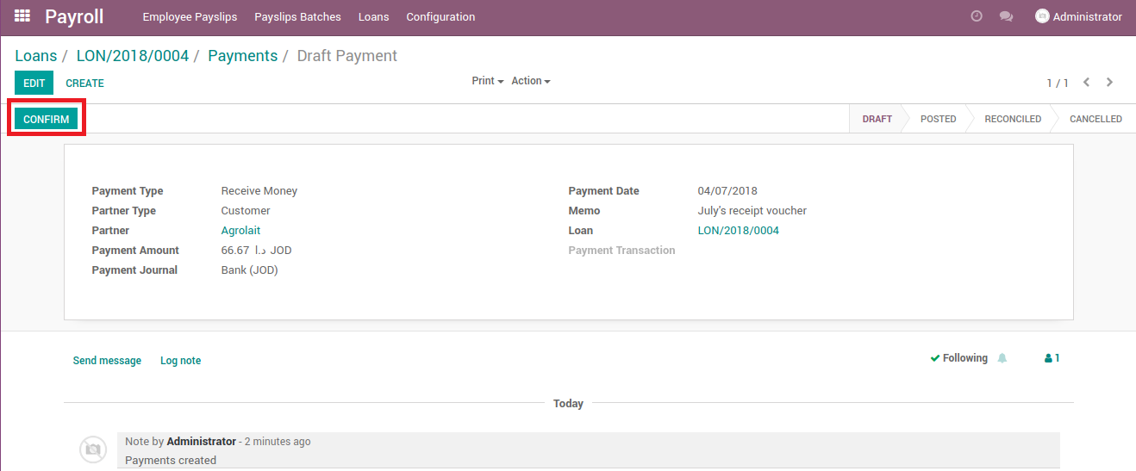
Once you create a receipt voucher it will be listed under “Receipts” smart button.
The reflection of the receipt voucher is in “Accounting” module as a customer payment.

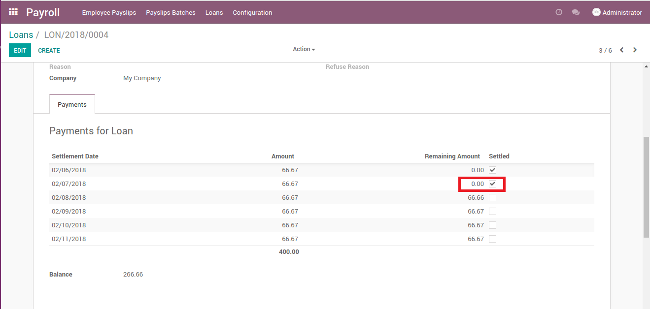
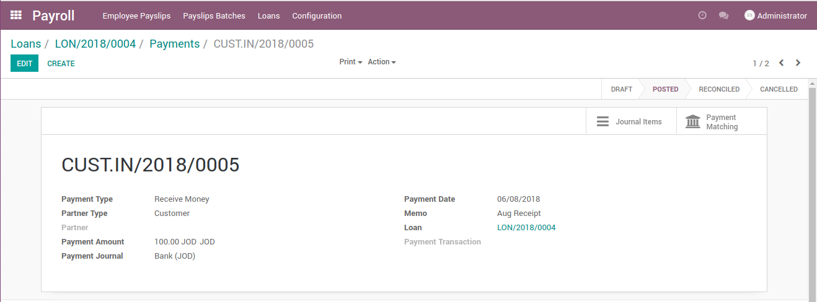
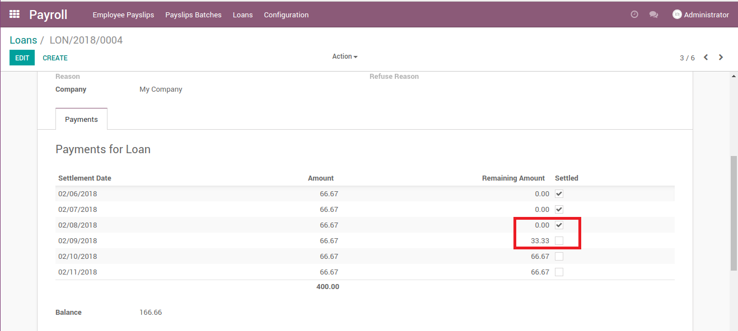

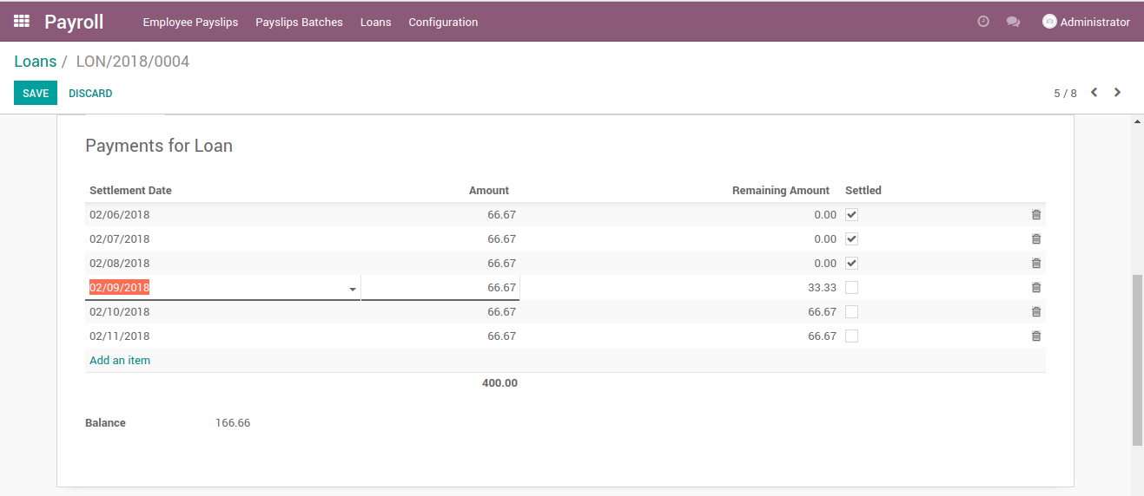
In case of postponing a payment change the date in the populate section.

Access Rights
Payroll users
Manager: Is able to create,view & approve loans.
Officer: Is able to create,view loans.
Employee: can create his own loans.

There are two levels of approval for loans:
1- HR manager approval.
2-Accounting manager approval.

